**Experiment Run**

**Experiment Run Report**

**Experiment Title:** Numerosity-Based Categorization - Experiment Run 2

**Date:** 21/02/2025

**Researcher:** Karoki Evans Njogu

**1. Experiment Details**

| **Parameter** | **Value** |
| --- | --- |
| Seed | 42 |
| Dataset Size | 5000 samples |
| Image Size | 128x128 pixels |
| Categories | Few (1-5), Medium (6-15), Many (>16) |
| Batch Size | 64 |
| Learning Rate | 0.0005 |
| Epochs | 20 |
| Optimizer | AdamW |
| Dropout Rate | 0.3 |
| Weight Decay | 1e-4 |
| Loss Function | CrossEntropyLoss |
| Early Stopping | Yes (Patience = 5) |
| Device Used | GPU – NVIDIA L4 |

**2. Experiment Setup**

* **Dataset:** Synthetic Dot Patterns
* **Model Architecture:** Residual CNN with three convolutional layers and fully connected layers.
* **Training Strategy:**
  + Train on 70% of data.
  + Validate on 15%.
  + Test on 15%.
* **Evaluation Metrics:**
  + Accuracy
  + Loss Curves
  + Confusion Matrix
  + Precision, Recall, and F1-Score

**3. Training & Validation Performance**

**3.1 Loss and Accuracy Trends**

| **Epoch** | **Train Loss** | **Validation Loss** | **Validation Accuracy (%)** |
| --- | --- | --- | --- |
| 1 | 1.0817 | 0.4664 | 78.00% |
| 2 | 0.2430 | 0.1957 | 91.87% |
| 3 | 0.2106 | 0.3036 | 88.27% |
| 4 | 0.2058 | 0.1886 | 92.67% |
| 5 | 0.1858 | 0.1617 | 93.60% |
| 6 | 0.1815 | 0.2017 | 92.53% |
| 7 | 0.1355 | 0.3013 | 87.33% |
| 8 | 0.1102 | 0.2299 | 90.93% |
| 9 | 0.1056 | 0.2553 | 90.13% |
| 10 | 0.0844 | 0.2127 | 91.20% |

**3.2 Loss Curve & Accuracy Plot**

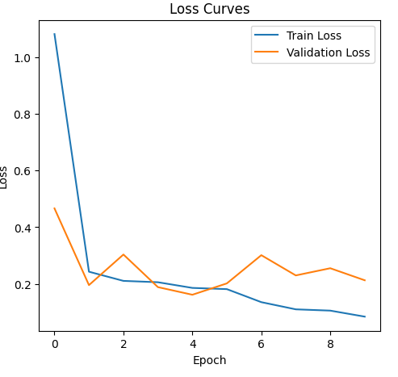

**4. Test Set Evaluation**

**Final Test Accuracy:** 90.53%

**4.1 Confusion Matrix**

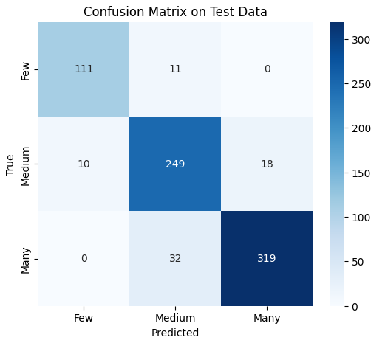

**4.2 Classification Report**

| **Class** | **Precision** | **Recall** | **F1-Score** | **Support** |
| --- | --- | --- | --- | --- |
| Few | 0.92 | 0.91 | 0.91 | 122 |
| Medium | 0.85 | 0.90 | 0.88 | 277 |
| Many | 0.95 | 0.91 | 0.93 | 351 |

**5. Observations & Insights**

* **Key Findings:**
  + The model achieved 91.20% validation accuracy, with a 90.53% test accuracy, showing a stable improvement over Run 1.
  + The dropout rate of 0.3 helped reduce overfitting compared to previous runs.
  + The AdamW optimizer contributed to smoother weight updates and stabilization.
* **Error Analysis:**

* + The Medium category remains the most misclassified class, though recall improved compared to previous runs.
  + Some confusion still exists between Medium and Many categories.
  + Training loss decreases smoothly, but validation loss fluctuates slightly, indicating minor overfitting.
* **Next Steps:**
  + Reduce learning rate to further stabilize training.
  + Increase batch size for better generalization.
  + Increase dropout to regularize the model further.
  + Slightly increase weight decay to 5e-4 to encourage smaller weights.

**6. Conclusion**

This run demonstrated the effectiveness of using AdamW, weight decay, and dropout in improving classification performance. However, some overfitting and class confusion still persist. The next run will focus on optimizing regularization strategies further to enhance generalization.

**7. Additional Notes**

* Reproducibility was ensured by setting a fixed random seed and using pre-saved datasets.
* This run also followed the structured experiment template, making future runs easy to compare.
* Some variability in validation loss was observed, which may indicate the need for better regularization techniques.
* Early stopping was applied, preventing overfitting, but further adjustments may be needed.